|  |  |  |
| --- | --- | --- |
| Customer Name |  |  |
| Phone |  |  |
| Email |  |  |
| Payment | Credit Card, Venmo to @vidaeatscatering, Cash in store |  |

|  |  |  |  |  |  |
| --- | --- | --- | --- | --- | --- |
| Item | Special requests/notes | Pickup Date | Quantity | Unit Price | Total Line Amount |
|
|  |  | 23rd/24th |  |  |  |
|  |  | 23rd/24th |  |  |  |
|  |  | 23rd/24th |  |  |  |
|  |  | 23rd/24th |  |  |  |
|  |  | 23rd/24th |  |  |  |
|  |  | 23rd/24th |  |  |  |
|  |  | 23rd/24th |  |  |  |
|  |  | 23rd/24th |  |  |  |
|  |  | 23rd/24th |  |  |  |
|  |  | 23rd/24th |  |  |  |
|  |  |  |  | Total Paid |  |

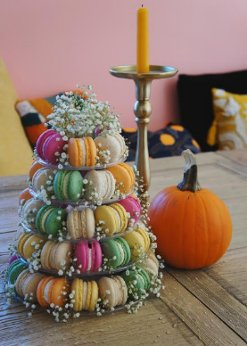

Product Descriptions:

1. **Denver Macaron: Fall Macaron Tower $195**

“Brighten All your fall events with out beautiful fall macaron tower, perfect as a centerpiece or an addition to a treats table! The fall tower has 5 tiers featuring 6 of our favorite fall flavors:

8-Pistachio 8-Raspberry Almond 8-Horchata 9-Bourbon Apple Cider 9-Banana Walnut Bread 8- Café Latte

*Vegan/GF*

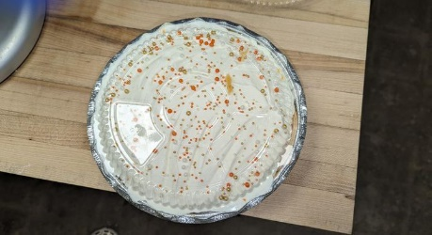

1. **Barton House Foods: Chiffon Pumpkin Pie**  **$27**

A light and fluffy pumpkin custard, flavored with hints of ginger, cinnamon and clove, topped with stabilized whipped cream. 9” pie, *contains eggs, dairy, wheat*

1. A brown bag with white label

   Description automatically generatedA bag of tea with a label

   Description automatically generated**Hearth & Seoul Shop: Seasonal Tea** **Blends**, single serve scooper included! **$18**

Loose Leaf Pumpkin Spice Black Tea, 8-10 servings/order, features rich, *caffeine-free* vanilla rooibos, warming pumpkin pie spice, indulgent cocoa nibs and cinnamon chips, this blend captures the essence of fall in every sip.

Loose Leaf Belly Bloat Tea, 8-10 servings/order, full of nourishing and calming herbs to let go of a stressful day and relax into evening. Includes Chamomile, Peppermint, Fennel, Persimmon Leaf.

1. A group of desserts in a box

   Description automatically generated**Le Clare’s Patisserie Fashion Eclairs:**

Entremets meets éclair for this perfect shareable flight of seasonal flavors to share with your family or friends or personal dessert!

Box of 6- 5” Fashion Eclairs, only available for PreOrders **$72**

Spicy Cranberry & Thyme - Blood Orange & Dark Chocolate -Maple Macadamia

Spiced Apple & Toffee - Bourbon Chocolate Pecan - Ube Leche

1. A cake with flowers on top

   Description automatically generated**Le Clare’s Croquembouche Centerpiece** 14” Tall, serves around 12 **$200**

Cream Puff Tower filled with vanilla custard and dipped in caramel to build this stunning, classic French centerpiece.

Scan the QR code to get PDF of this file to print and email order to leclaresdenver@gmail.com